**Objects and Their Internal Representation in JavaScript**

**Introduction:**

JavaScript, one of the most popular programming languages, is known for its versatility and flexibility. At the heart of JavaScript's power lies its ability to work with objects. Objects are fundamental to JavaScript, and understanding their internal representation is crucial for any developer looking to harness the full potential of the language. In this blog post, we'll delve into the world of JavaScript objects, exploring how they are internally represented and how this knowledge can be applied in your coding endeavors.

**What are JavaScript Objects?**

In JavaScript, an object is a data structure that stores collections of key-value pairs. Objects can represent real-world entities, abstract data structures, or even functions. They are versatile and can be used to model a wide range of concepts. Here's a simple example of an object:

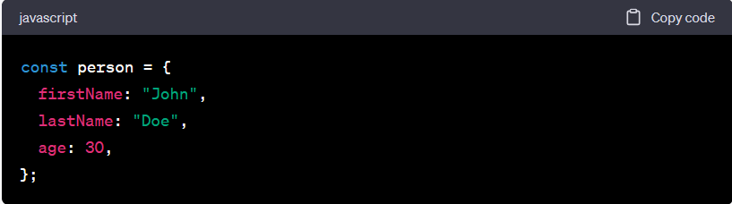In this example, **person** is an object with three key-value pairs: **firstName**, **lastName**, and **age**. Understanding how JavaScript represents objects internally can help you work with them more effectively.

**Object Properties and Their Representation**

**Property Names**

In JavaScript, object property names are always strings or symbols. When you define a property name without quotes, JavaScript automatically converts it to a string. For example:

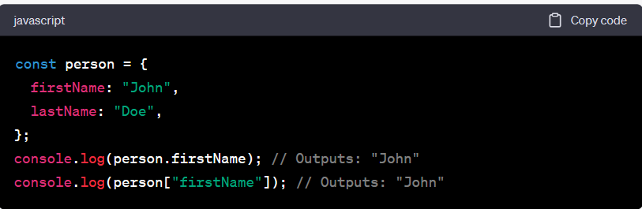**Property Values**

Property values in JavaScript objects can be of any data type, including numbers, strings, functions, other objects, and even **undefined**.

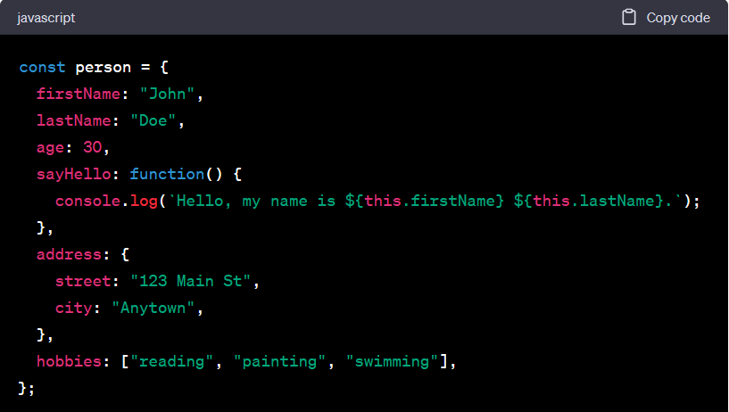In the above example, the **person** object contains various data types, including a function (**sayHello**), another nested object (**address**), and an array (**hobbies**).

**Internal Representation of Objects**

JavaScript engines, such as V8 (used in Chrome) or SpiderMonkey (used in Firefox), handle objects differently behind the scenes. However, there are some common elements in their internal representations:

1. **Hidden Classes**: JavaScript engines use a concept called hidden classes or shapes to optimize property access. When you add properties to an object, the engine creates a hidden class to represent its structure. This helps improve performance when accessing properties.
2. **Property Storage**: Objects store their properties in various ways, depending on the JavaScript engine. Some engines use a dictionary-like structure, while others use more efficient methods like inline caching.
3. **Prototypes**: Objects in JavaScript can be linked together through a prototype chain. Each object has a reference to its prototype object, allowing it to inherit properties and methods from higher up in the chain.
4. **Primitive Values**: JavaScript objects can also store primitive values (e.g., numbers, strings) as properties. When you access a primitive property, the engine automatically boxes and unboxes the value as needed.

**Practical Applications**

Understanding the internal representation of objects can have several practical benefits:

1. **Performance Optimization**: Knowing how property access and manipulation work internally can help you write code that performs better. Avoiding property access in loops or optimizing property names can make a significant difference in execution speed.
2. **Object-oriented Programming**: A deep understanding of how objects and prototypes work can improve your object-oriented programming skills in JavaScript. You can create complex inheritance hierarchies and share behavior efficiently.
3. **Memory Management**: Understanding how objects are stored in memory can help you manage memory more effectively, especially in memory-constrained environments like browsers.
4. **Debugging**: When debugging, knowing how objects are structured internally can assist you in identifying issues with your code, such as unexpected property behavior or memory leaks.

**Conclusion**

JavaScript objects are fundamental to the language's power and versatility. They allow you to model real-world entities, data structures, and more. By understanding their internal representation, you can write more efficient, maintainable, and optimized code. Whether you're building web applications, server-side code, or working with data, a solid grasp of JavaScript objects will undoubtedly enhance your development skills. So, dive deeper into the world of objects, explore the intricacies of prototypes and hidden classes, and unlock the full potential of JavaScript. Happy coding!